IQX Windows Search Test App User Guide

This application will test the IQX interface to the Windows Search service.
There are 4 parts to the testbed app; Windows Search criteria panel, Tests panel, Status panel, Results panel. There are also a few menu options to help detect current OS configuration.

Menu Options

File > Reset Testbed
This will reset the application back to original start up configuration, it will close any open database connections, reset all the textboxes, list box and checkboxes.
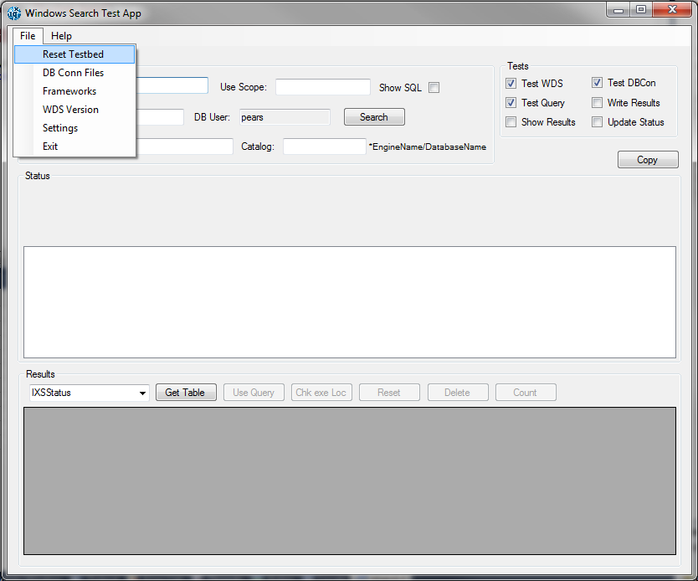
File > DB Conn Files
This will display information about the Database Files required. The first entry is the SQL Anywhere dll the testbed was compiled to use. The next 3 entries are the 3 database files required for the interface. If the files are present in the folder where the testbed is being run then the files version numbers will be shown. If they are not found then they will show as not found. All 3 database files versions need to match for the interface to work. For the testbed to work the 3 files must be same version as the first dll.
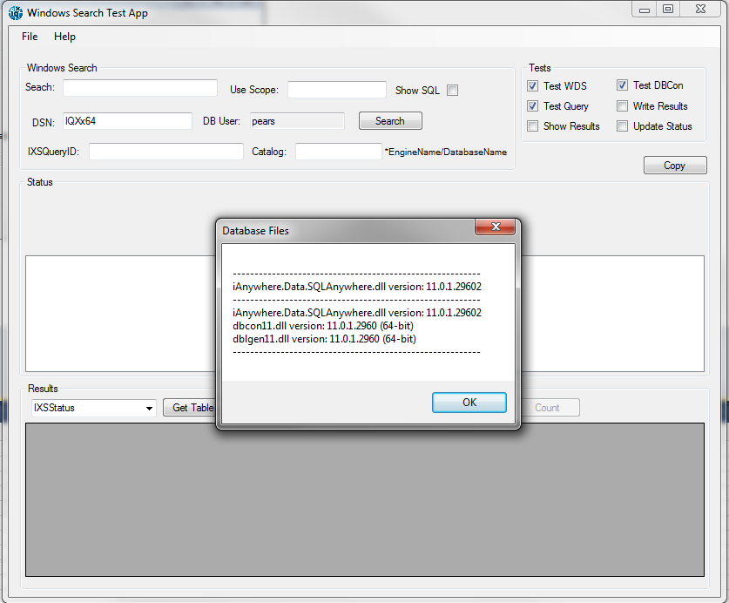
File > Framework
Shows the current .Net Frameworks installed on the host machine.
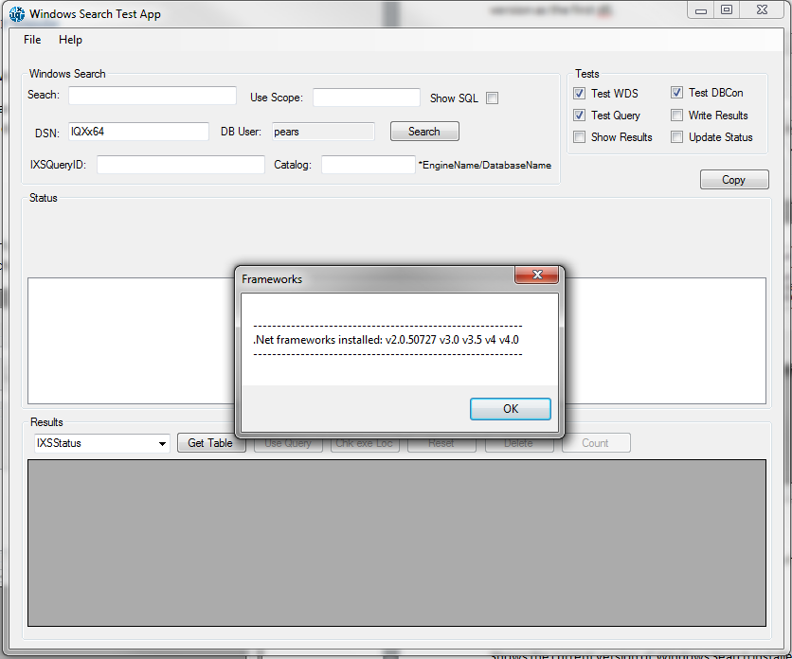
File > WDS Version
Shows the current version of Windows Search installed.
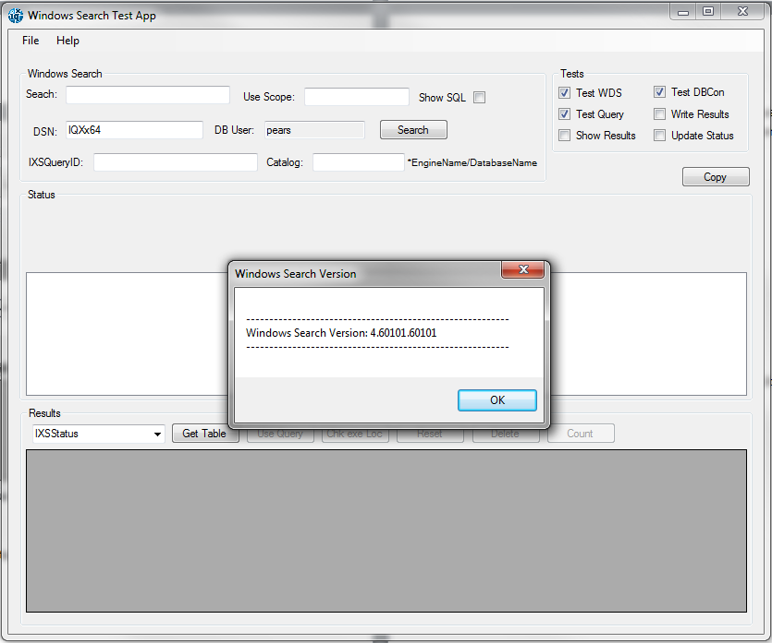
File > Settings
This shows the following values.
MinBulkCopy - This value sets minimum amount of results returned before it uses Sybase Bulk copy.
SABulkBatchSize - This value sets the Batch size for the Sybase Bulk copy.
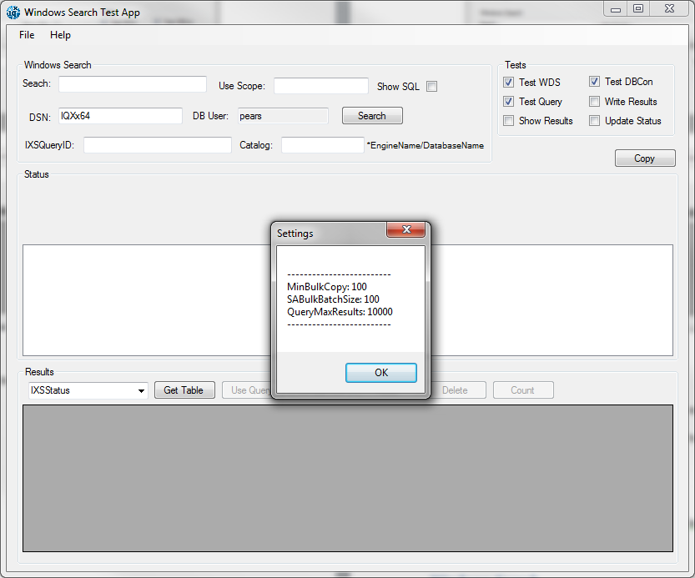
Help > About
Information about the current version of Windows Search Test App.
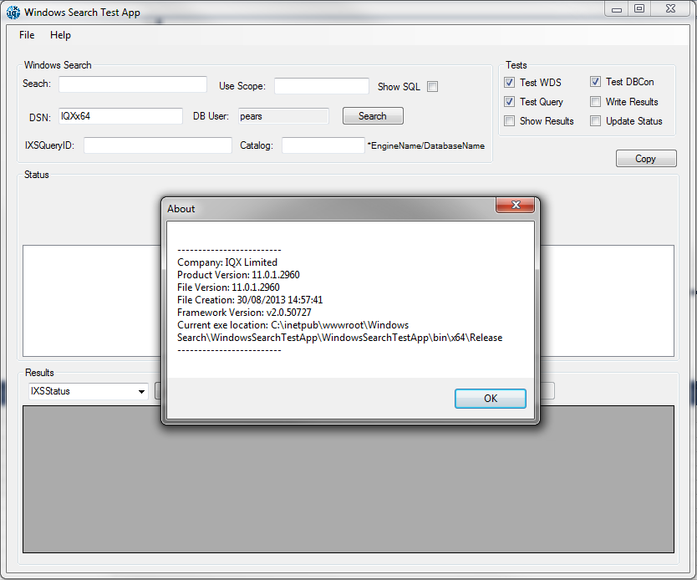
Windows Search

This is where you enter the parameters required for testing each part of the Windows Desktop Search component.
Search – Enter the search criteria here. This can be anything you like however make sure that the words or phrase used can be found manually within your test Cvs.
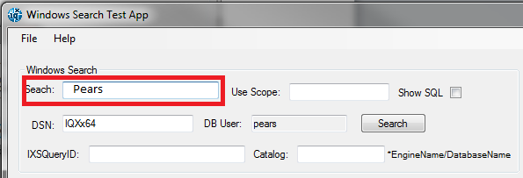
Use Scope – Enter the scope, generally this is the absolute path to the indexed folder to query.
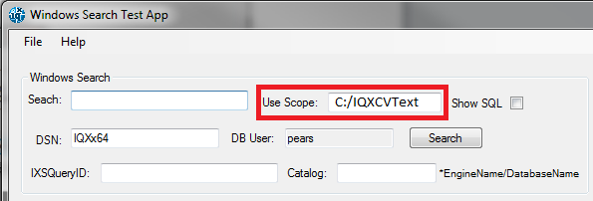
Show SQL – Check the show SQL checkbox to display in the Status pane the query built using the parameters supplied.
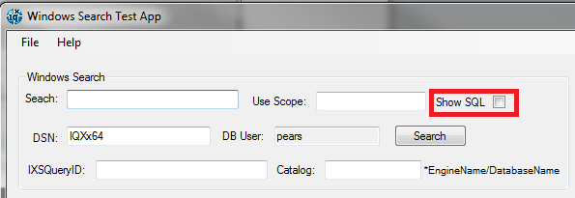
Example of the SQL produced when checking the Show SQL checkbox.
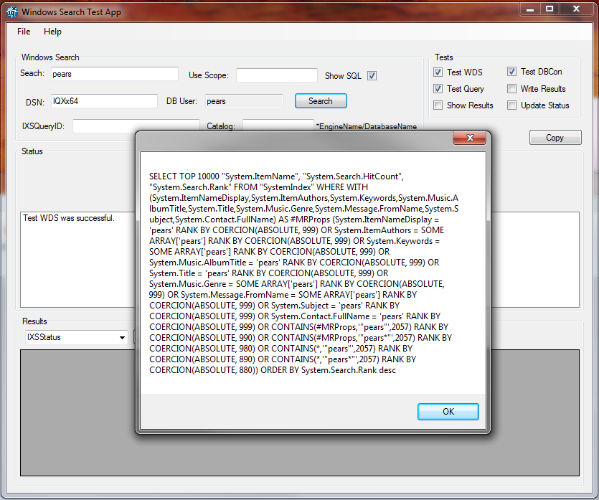
DSN – Enter the ODBC DSN name, take care that you use the 64bit version because the testbed will still work using the 32bit ODBC name but them fail to work within IQX.
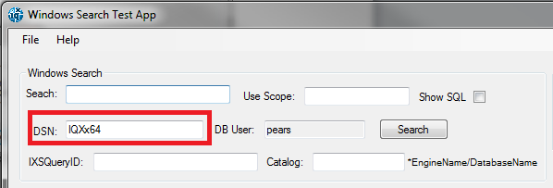
DB User – This is currently fixed and cannot be changed within the testbed. If you do require this to be a different user please ask IQX. The password for user pears is also hardcoded therefore if you have a different password for this user other than the IQX default then you will need to contact your system administrator.
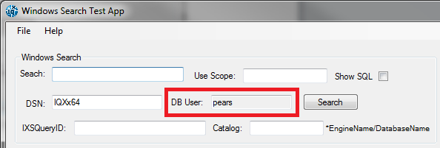
Search – Click the search button to start and run the required tests selected in the Test Panel.
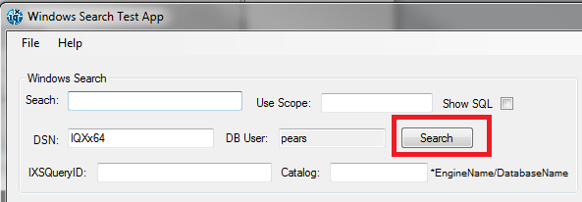
IXSQueryID – This is an IQX auto generated ID created when a Search is created to use the Index. It is used in conjunction with the Test Panel to retrieve data from the IQX database to use in the tests.
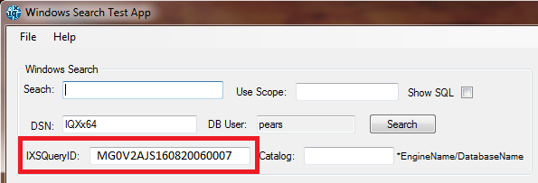
Catalog - This requires the Engine Name and the Database Name with a pipe “|” to separate them and without spaces in between.
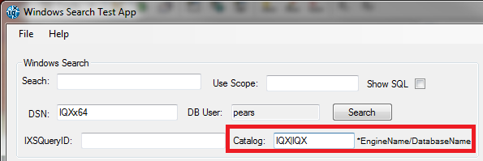

Tests

Test WDS – This will run the test to make sure the Windows Search service is running.
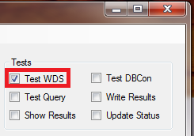
Test Query – This will run the test for the query using the information supplied in the Search box. For this test to run it must also run the Test WDS. Once you check Test Query it will automatically select Test WDS as you can’t test the Query without also testing the Windows Search service is still running.
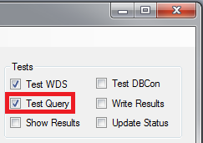
Show Results – The show results test will output the results of the Test Query test to the Status window.
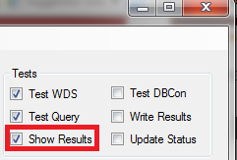
Test DBCon – This tests the connection to the database.
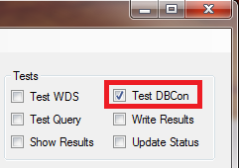
Write Results – Running this test requires that you run Test WDS, Test Query and Test DBCon. This will write the results into the IXSResults table in your IQX database.
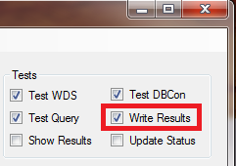

Update Status – This test will test the updating of the status field in the IQXStatus table. It requires a database connection therefore it will have to run the Test DBCon test as well.
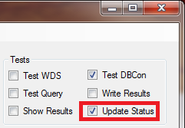
Status

The Status panel serves 2 purposes to display any error messages occurring during the tests and also to display the results of each test.
Below shows an example where the Test WDS and the Test Query was successful but the Test DBCon failed.
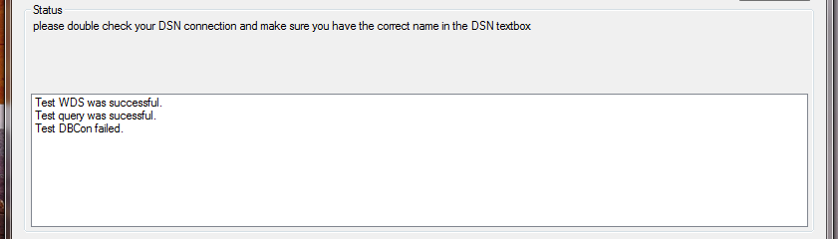
Results

The results panel is for displaying the IQX tables for the Index Server from the IQX database. When using this part of the Testbed you must first make sure you have a working Database Connection therefore you must make sure the Test DBCon test is successful. A DSN name is required in the DSN field for both the Test DBCon test and to retrieve the table from the database.
Select the table you want to view from the dropdownlist and click get table.
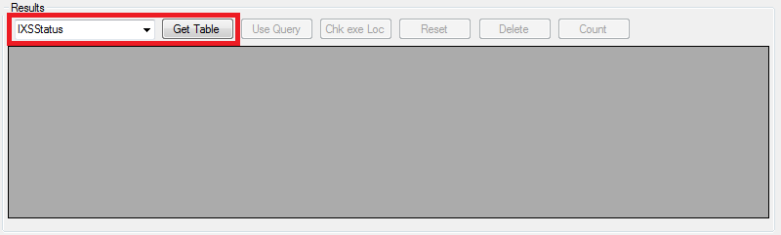
Select table IXSSearchDefinition from the dropdownlist will load the Index configuration record from the IQX database.
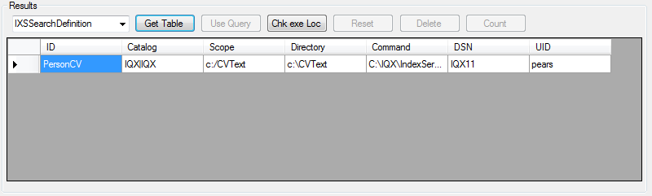
Here you can check to make sure that the settings are entered according to the recommend settings specified within the Windows Search Installation Manual.
Check EXE Location

You can use the “Chk exe Loc” button to check that the IXSDBDaemonx64.exe file is in the location that is specified in the Command field.
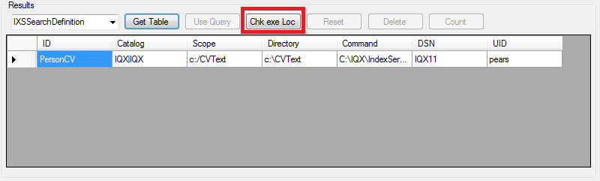
Reset Status in IXSSatus Table

You can reset the status field by loading the IQXStatus lable into the Results panel, select the row for the record you want to reset and then press the reset button. This will reset the Status on the query back to 0.
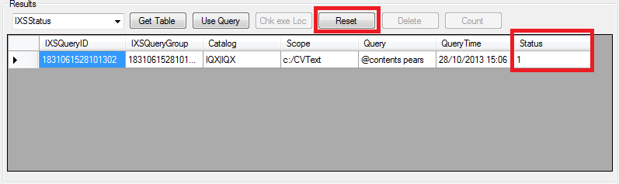
View IXSResults

You can view the results written in the database by loading the IXSResult table into the results panel.
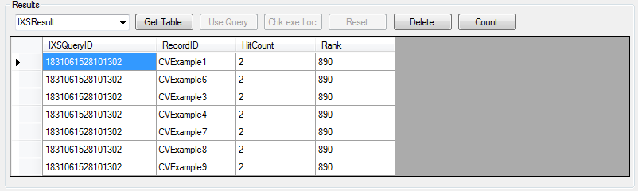
Count the IXSResults

You can get a count of the records in the IXSRsults table by clicking the count button.
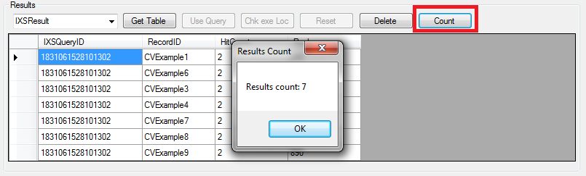
Reset the IXSResults table
You can remove all the records from the IXSResult table by clicking the delete button. It will only delete the records associated with the IXSQueryID you have entered into IXSQueryID field you have filled in the Windows Search panel.
